
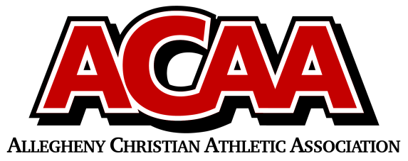
Official league roster – Varsity Basketball

School Name: Blair County Christian
Team Colors: Green/White
Overall Wins ___ Losses ____
Number | Name | Year | Position | Homeschool
3 | Braxton Walter | 11th | Guard
24 | Bradley Maretich | 11th | Center
1 | Jonathan Marucci | 10th | Guard
15 | Aidyn Lundy | 10th | Forward
21 | Julian Sponsler | 10th | Guard
5 | Caleb Hileman | 10th | forward
23 | Malachi Teis | 10th | Forward | X
0 | Colton Walter | 9th | Guard | X
13 | Donovan Bickings | 9th | Forward
22 | Silas Marucci | 9th | Guard

Head Coach: Andrew Fries
Asst. coach: MICAIAH MARUCCI
ACAA Wins ___ Losses ____

Official ACAA League Team Roster. to be submitted to the scorer’s table before each game.

